Attended Install of Windows XP Professional
This article covers attended installations of Windows XP Professional from a CD-ROM.
Installing Windows XP Professional from a CD-ROM to a clean hard disk consists of these four stages:
Running the Setup program - Partitions and formats the hard disk (if required) for the installation to proceed and copies the files necessary to run the Setup Wizard.
Running the Setup Wizard - Requests setup information about the local workstation where the installation is taking place.
Networking components - Installs the networking components that allow the computer to communicate with other computers on the local network.
Completing the installation - This final phase copies files to the hard drive and configures the final stages of the setup.
There are some noted differences in the Windows XP Professional installation and older Windows NT4 and Windows Professional installations.
The design of the installation program assumes that your system has the ability to boot directly from a CD-ROM or that you will use a Windows 95/98/ME boot floppy to begin installing from a CD. The ability to directly create setup floppies has been dropped from Windows XP. Setup boot disks are available only by download from Microsoft. The Setup boot disks are available so that you can run Setup on computers that do not support a bootable CD-ROM.
There are six Windows XP Setup boot floppy disks. These disks contain the files and drivers that are required to access the CD-ROM drive through generic PCI drivers and begin the Setup process.
If your computer does support booting from a CD-ROM, or if network-based installation is available, Microsoft recommends that you use those installations methods.
Setup will not prompt the user to specify the name of an installation folder unless you are performing an unattended installation or using winnt32 to perform a clean installation.
By default, the Setup Wizard installs the Windows XP Professional operating system files in the WINDOWS folder. If this folder exists on the partition you have chosen for the install, setup will warn you that you are about to overwrite the current operating system installed on that partition. In order to keep it (e.g. dual or multi booting scenario) you would need to choose another partition for the installation.
To start the Setup program, insert the Windows XP Professional installation CD-ROM in your CD-ROM drive
If an operating system is detected on the hard drive, the following message will appear:
In this scenario, you would need to press any key on the keyboard to continue with the CDROM installation.
After the computer starts, a minimal version of Windows XP Professional is copied into memory. This version of Windows XP Professional starts the Setup program.
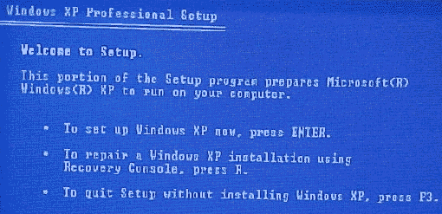
After all of the files are copied and the system is restarted, the text-mode portion of Setup is started which prompts you to read and accept a licensing agreement.
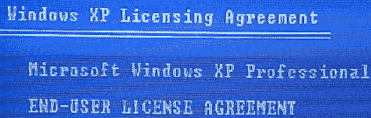
You would select "F8-I agree" to continue. (If you elect not to accept the agreement, the installation will end)
You are then prompted to select a partition on which to install Windows XP Professional. You can select an existing partition or create a new partition by using any unpartitioned free space on the hard drive(s).
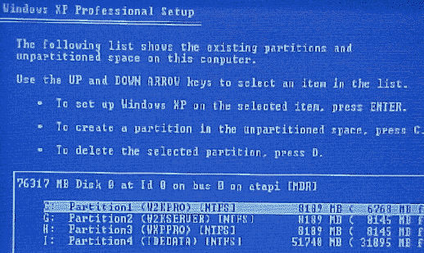
(The above example shows a partitioned and formatted drive)
Once a partition has been selected the next step is to select a file system for the new partition. Next, Setup formats the partition with the selected file system. (This would assume that a file system didn't currently exist. In this example, one already does and it is formatted in NTFS so I have elected to leave it as is. Any formatting done here during setup will destroy any existing data on the partitions formatted.)
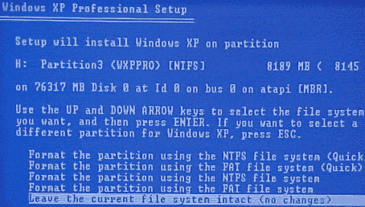
From here Setup copies files to the hard disk and saves configuration information.
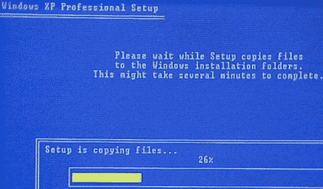
Setup restarts the computer once the file copy is completed and then starts the Windows XP Professional Setup Wizard, the graphical user interface (GUI) portion of Setup.
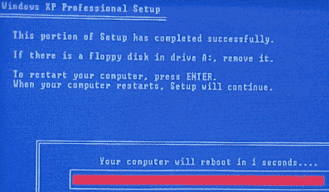
The GUI-based Windows XP Professional Setup Wizard is the next stage of the installation process.
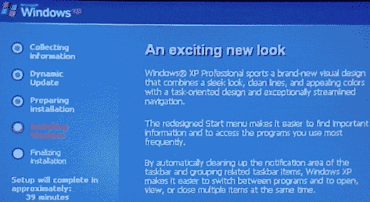
Regional settings - In this section you are able to customize settings to your language and where you live as well as setup Windows XP Professional to use multiple languages and regional settings.
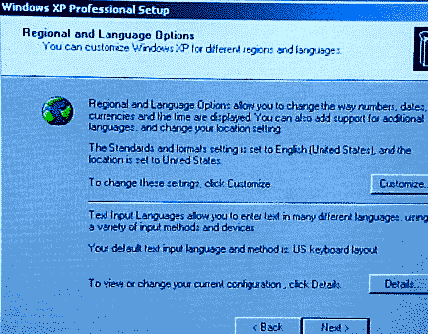
Personalize your Software - In this section you can enter the name of the person and the organization to which this copy of Windows XP Professional is licensed. This can be your own name and nothing in the organization field or the name of the company in both places if this installation is being performed in a place of business. Software installed on the system later will often use this information for product registration and document identification.
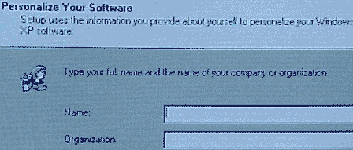
Your Product Key - This page is where you enter your 25-character product key in order to install the software.
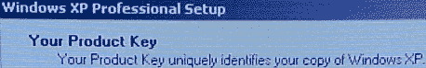
If you incorrectly type the key, an error message will be generated.
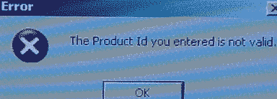
Computer Name And Administrator Password - Here you enter a name for the computer or use the auto generated one that Windows XP Professional provided.
The computer name will always display in all uppercase letters, no matter how you type it. The name is not case sensitive.
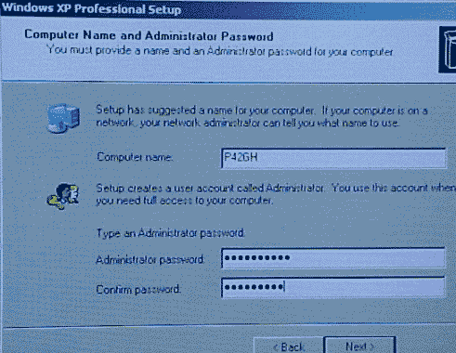
In the Administrator Password box on the same screen, you will enter the password to be used for the administrator account and in the Confirm Password box you will re-enter it to make sure that it is entered correctly.
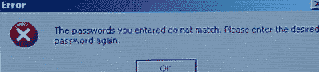
If the passwords do not match, the above error message will appear and you will need to enter them again.
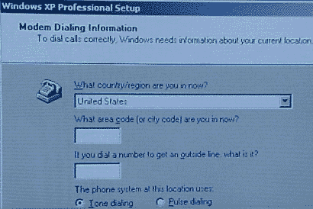
Modem Dialing Information - This section will begin only if an installed modem has been found on your system.
Enter the correct country or region if it is not selected. (It should match your selection from the Regional settings page.) Type your area code or city code and any number you might need to dial to get an outside line. You can also select either tone or pulse dialing on this page as well.
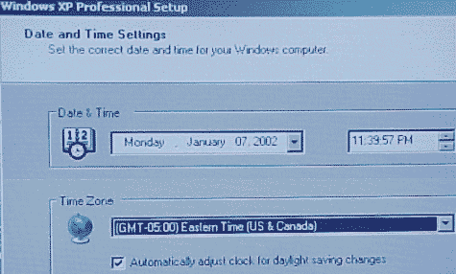
Date and Time Settings - This section of Setup allows you to verify that the correct date, time and time zone are entered and whether or not the system should adjust itself automatically at the daylight savings times events each year.
Network Settings - The next section of setup deals entirely with installing the Windows XP Professional networking components on your system.
Installing Windows XP Professional networking components involves the following processes:
Detect network adapter cards - The Setup Wizard detects and configures any network adapter cards installed on the computer. By default, it attempts to locate a DHCP server on the network. If none is found it will use an Automatic Private IP Addressing (APIPA) IP address. (The APIPA IP address feature of Windows XP Professional automatically configures a unique IP address from the range 169.254.0.1 to 169.254.255.255 and a subnet mask of 255.255.0.0 when TCP/IP is configured for dynamic addressing and a DHCP server is not available.)
Select networking components - The Setup Wizard prompts you to choose typical or customized settings for networking components.
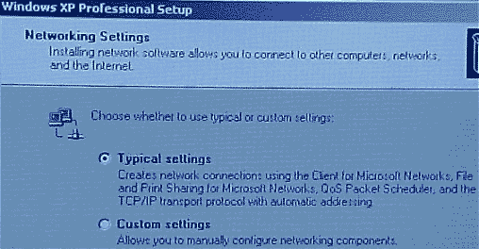
The Typical (selected by default) installation includes the following options:
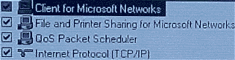
- Client For Microsoft Networks. Allows your computer to access network resources.
- File And Printer Sharing For Microsoft Networks. Allows other computers to access file and print resources on your computer.
- QoS Packet Scheduler. Helps provide a guaranteed delivery system for network traffic, such as Internet Protocol (TCP/IP) packets.
- Internet Protocol (TCP/IP). Allows your computer to communicate over local area networks (LANs) and wide area networks (WANs). TCP/IP is the default networking protocol.
You can install other clients, services, and network protocols during the Windows XP Professional installation by choosing CUSTOM, but it is recommended that you wait until after the installation has completed to add additional services. (The exception would be if the lack of these services would prevent the system from coming online to your network properly upon restart.)
Workgroup or Computer Domain - This section allows you to choose to join a domain for which you have administrative privileges or to join a local workgroup. You can create the computer account in the domain you are joining ahead of time or during installation. (The Setup Wizard prompts you for the name and password of a user account with authority to add domain computer accounts if you elect to create the account during the Windows XP Professional installation).
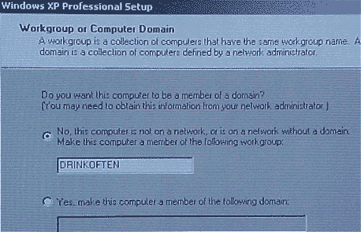
After installing the networking components, Setup starts the final steps of the installation process, which include:
- Installs Start menu items - Shortcuts that will appear on the Start menu are installed and configured during this stage.
- Registers components - The configuration settings that you specified earlier during the install are configured now.
- Saves the configuration - The Setup Wizard saves your entered configuration settings. Once the system is restarted, the computer uses this configuration by default.
- Removes temporary files - Any files used by the Setup Wizard that are no longer needed are deleted.
- Restarts the computer - The computer is automatically restarted. This is the final step of the Setup Wizard.
Upon restart, the computer will either boot directly to Windows XP Professional or it will bring up the operating system selection window (the text of the BOOT.INI file) if you have more than one operating system installed.
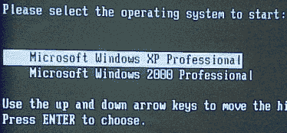
After you start Windows XP for the first time, you will come to the Welcome to Microsoft Windows screen to finish setting up your computer. Click on the Green NEXT arrow at the bottom right hand corner of the display.
The system will then check to see how you will connect to the Internet. If Windows cannot detect the settings it will prompt you for input. (You can also select SKIP to by pass this section).
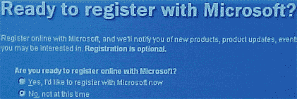
The Registration of your Windows XP Professional software IS NOT REQUIRED. You can skip this step and never go back to it.
The Windows Product Activation screen appears next. Windows Product Activation has been designed by Microsoft it protect their intellectual property as much as possible from software piracy. According to Microsoft through the setup feature, you do not need to send any information at all when you activate the product, not even a name. This step is required, at this time or within the first 30 days.
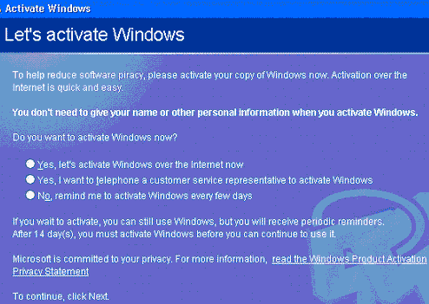
If you decide to skip this registration step now, you will only be able to use Windows XP Professional for 30 days. At that time, the operating system will not function without activating the product. You will have no other option but to either blow the partition away and reinstall the OS for another 30 days or activate the software.
If you skip this step, Windows XP will periodically remind us during our 30-day period to Activate the product.
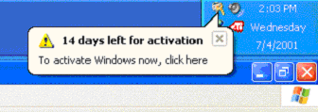
The next screen we are brought to is the Internet Access screen, which allows us to configure our Internet connection at this time as well. You do have the option to skip this step as well.
The next screen that appears is the User Setup screen. On this setup page you are able to enter the name of each person that will have local access to this computer. If you choose to do this now, Windows XP Professional would create a separate user account for each name entered.
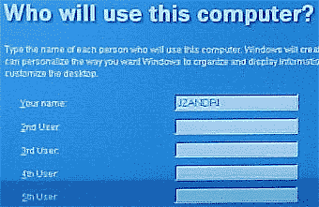
These names would first appear on the Welcome Screen in alphabetical order. At that point, users would be able to select their name from the Welcome screen to use the computer. The local administrator can use User Accounts in the system Control Panel to assign these users with passwords and system permission limits. It is also where additional users can be created, in lieu of doing here or in addition to entering some here.
At least one name needs to be entered.
This first user becomes a local administrator by default.
Best of luck in your studies and please feel free to contact me with any questions on my article and remember, "If a bad guy can alter the operating system on your computer, it may not be your computer anymore"
Jason Zandri

